Home Challenge

## Fractals

Week 7 – Challenge 4

### Problem I: *The Koch curve*

The Koch snowflake is a mathematical curve and one of the earliest fractal curves to have been described. It is based on the Koch curve, which appeared in a 1904 paper titled "On a continuous curve without tangents, constructible from elementary geometry" (original French title: Sur une courbe continue sans tangente, obtenue par une construction géométrique élémentaire) by the Swedish mathematician Helge von Koch.

**Algorithm:**

**Function** Koch_Curve(turtle, length, degree)

**if** degree == 0 **then**

turtle must draw a segment of size length

**else**

length := length / 3

degree := degree – 1

korch_curve (turtle, length, degree) # First segment

turtle turn left 60°

korch_curve (turtle, length, degree) # Second segment

turtle turn right 120°

korch_curve (turtle, length, degree) # Third segment

turtle turn left 60°

korch_curve (turtle, length, degree) # Fourth segment

Using the algorithm above and the Turtle Module (look on Google), draw the Koch Curve.

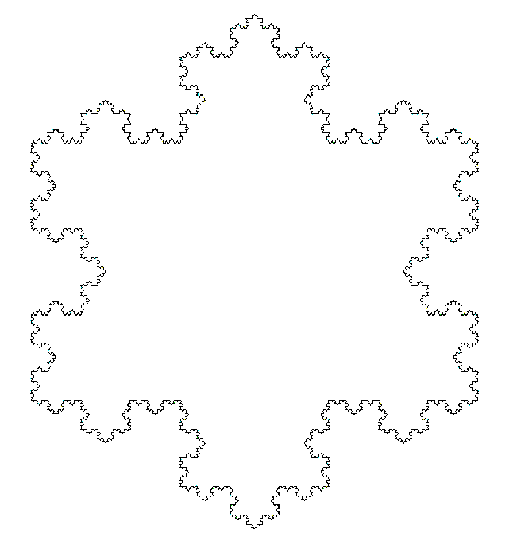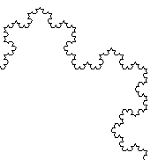

### Problem II: *Sierpinski triangles (or gasket)*

Try to draw the following fractal. It can be seen as being produced by subtracting triangles from the interior, instead of adding them to the surface as in the Koch curve. Why not try some filling colours?

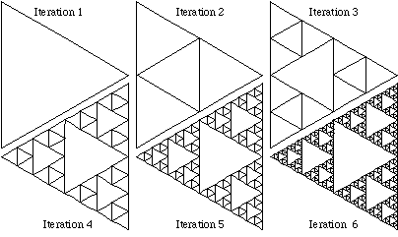

### Problem III: *Binary Trees*

Note you could try other types of trees. Could you draw a fractal tree were branches never cross over each other?

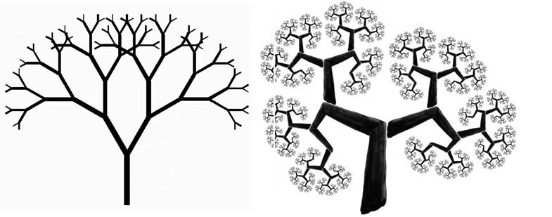

Figure 1: Fractal trees, with overlapping branches (left), and non-overlapping branches (right)

### Problem IV: *Soddy’s circles & Apollony fractal*

The Apollony fractal is created by starting with three mutually tangential circles as shown below. There are two circles which have these three circles as their tangent, they are called the inner and outer Soddy circles. The derivations of the radius of the inner and outer Soddy circles were studied by Frederick Soddy around 1936. The Apollony fractal is created by repeatedly filling the gaps between the circles with the inner Soddy circle. The first two iterations are shown below.

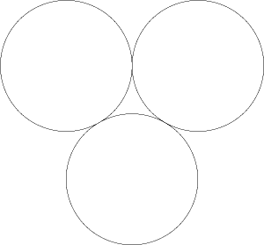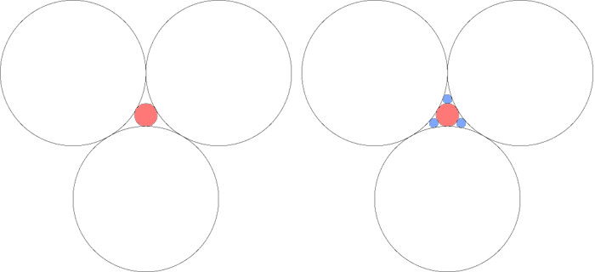

Starting point

Iteration 1

Iteration 2

The following is the Apollony fractal iterated to a "depth" of 1000 circles. The normal interpretation is to consider the plane to be solid and the circles are cutting out holes, as such the area tends to zero.

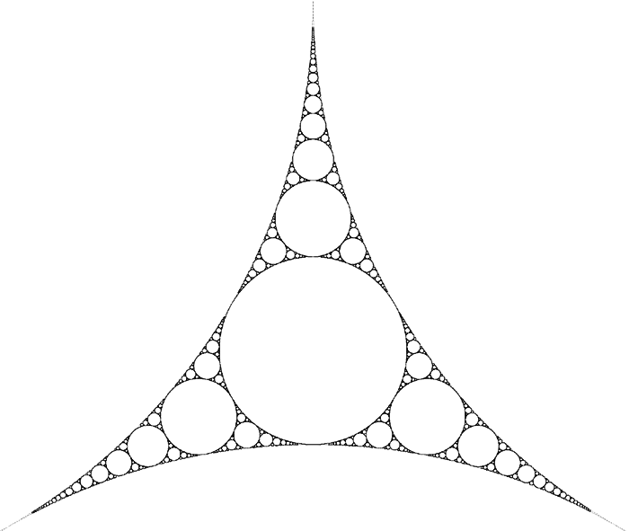

The curvature (or bend) of a circle is defined as $k = ±1/r$. When trying to find the radius $r_{inner}$ of the fourth inner circle tangent to three given kissing circles, the equation is best rewritten as:

$$k_{inner}=k_{1}+k_{2}+k_{3}+2\sqrt{k_{1}k_{2}+k_{1}k_{3}+k_{2}k_{3}}$$

$$r_{inner}=1/{k_{inner}}$$

Where $k_{i}$ is the curvature of the ithcircle.

To determine a circle completely, not only its radius (or curvature), but also its centre must be known. The relevant equation is expressed most clearly if the coordinates (x, y) are interpreted as a complex number $z = x + iy$. Given three circles with curvatures $k_{i}$ and centres $z_i$ (for i = 1...3), once $k_{inner}$ has been found using the previous equation, one may proceed to calculate $z_{inner}$ by using:

$$z_{inner}=\frac{z_{1}k_{1}+{z_{2}k}_{2}+{z_{3}k}_{3}-2\sqrt{k_{1}k_{2}z_{1}z_{2}+k_{1}k_{3}z_{1}z_{3}+k_{2}k_{3}z_{2}z_{3}}}{k_{inner}}$$

#### Part A

Implement a recursive algorithm to draw the Appolony fractal.

#### Part B: As seen in the TV series D:\lblot\Dropbox\York University\Teaching\Teaching 2014-15\TPOP 2014-15\Practical-2014-15\extant.jpg

The Appolony fractal can also be used to draw the following picture. This time we are using the outer Soddy circle as well.

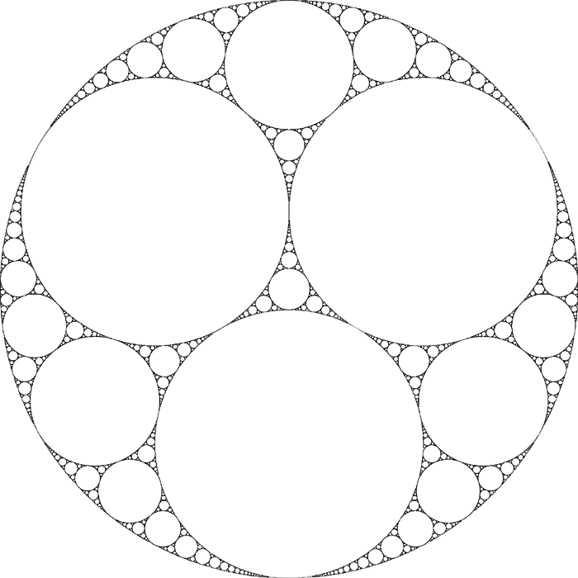

The radius of the outer is given by:

$$k_{outer}=k_{1}+k_{2}+k_{3}-2\sqrt{k_{1}k_{2}+k_{1}k_{3}+k_{2}k_{3}}$$

$$r_{outer}=1/{k_{outer}}$$

The centre of the outer circle is calculated using:

$$z_{outer}=\frac{z_{1}k_{1}+{z_{2}k}_{2}+{z_{3}k}_{3}+2\sqrt{k_{1}k_{2}z_{1}z_{2}+k_{1}k_{3}z_{1}z_{3}+k_{2}k_{3}z_{2}z_{3}}}{k_{outer}}$$

Draw the fractal shown above.